■学術集会開催報告■

The Seating/Sitting Symposium 2025:
Reflections and Launching Global Collaborations

Kageyu Noro (Waseda University・ErgoSeating,Ltd.)
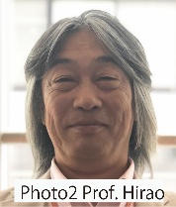

1. Introduction

Last May, the International Symposium on Sitting/Seating Comfort 2025 held in Japan was successfully concluded with the participation of many attendees. Through this symposium, we were reminded of the importance of broadening perspectives through the two themes of sitting/seating comfort and work, as well as the value of academic exchange.
Below is a brief introduction to the presenters' reports and their activities following the symposium.（Table 1 and Table2）
First, let me introduce Bernardino Ramazzini, ( Photo 1,November 5, 1633 - November 5, 1714). He is the symbolic figure of this event. He also symbolizes the mutual relationship between ergonomics and medicine. He became the symbol of the University through the advocacy of Dr. Kenzaburo Tsuchiya, the first president of the University. The University's Ergonomics Laboratory was also established on this premise.
Table 1 Four Distinct Features of This Symposium
- Inviting four speakers from Europe, along with two reports from startup companies.
2. Presenting comfort research from different perspectives.
- Exploring the history of chairs in Japan.
- Research by the younger generation that academic
societies should consider.
The day's time table is on the next page.
Refer to the proceedings for each speaker's title.
2.Prof. Akinari Hirao (Photo 2)
Product Ergonomics Design Laboratory in the Department of Design Engineering at Shibaura Institute of Technology.
Professor Hirao has been conducting experiments measuring body surface stiffness, particularly in the buttocks, since his time at Keio University, and I recall being inspired by this work
back then. This time, an experiment measuring pressure sensitivity by body region was introduced. As pressure sensitivity in the buttocks, thighs, and back has been measured, this holds great promise for advancing the interpretation of body pressure distribution in sitting. Whilst fundamental research, its application to seat design and similar fields is anticipated.
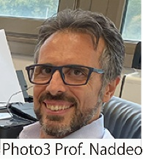
Professor Hirao will be organizing the next Comfort Congress 2027 in Tokyo in September 2027.

3.Prof. Alessandro. Naddeo (Photo 3) Associate Professor at University of Salerno (Italy) in Industrial Design Methods. In 2020 he had the National Academic Qualification as Full Professor.
Alessandro reports that the emergence and spread of new propulsion technologies (electrical-based) and new management logics (AI-based) will lead car designers to develop new design methods

4. Prof. Rosaria Califano (Photo 4)

Assistant Professor in the Dept. of Industrial Engineering, University of Salerno.
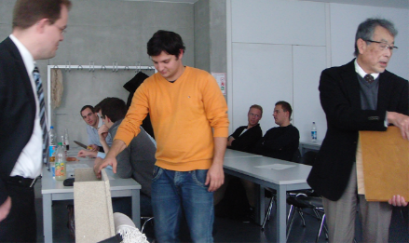
Driving Posture Recognition (DPR) is essential for driver's safety and comfort. Her study aims to actively monitor the driver's position through pressure mats in machine learning techniques. Based on completed and ongoing experiments, she proposes a new framework to explain the comfort model supported by these new experiments. This laboratory, part of the university's Department of Mechanical Engineering, is led by Prof. Naddeo and employs numerous staff members. The automotive manufacturers partnering with this laboratory are all leading companies, such as Ferrari.
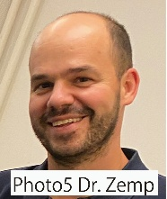
5.Dr. Roland Zemp (Photo 5)
Co-Founder and CEO of sensomative ag, a Swiss start-up developing textile-based sensor systems for real-world biomechanical applications.
Dr. Zemp reported on sensomative Wheelchair –The system integrates a thin fiber pressure mat and machine learning algorithms to detect sitting posture and pressure-relieving movements to reduce ulcer risk.
He recently (in October) reported to Professor Noro on his company's new developments as follows: sensomative partnered with a leading manufacturer of bike saddles and apparel to develop a specialized measurement tool for professional bike fitting, currently being refined and scaled up. sensomative is also collaborating with a company that is revolutionizing the orthopedic braces market, using its sensor technology for long-term monitoring and improved care.
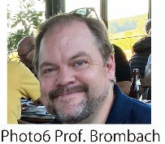
6.Prof. Johannes Brombach (Photo 6 )
A professor at the Hochschule in Munich, Germany. He will talk about GfA Next, a project of the German Society for ergonomics to get young people interested in research. This is a countermeasure against the decline in the number of society members, as is the case in Japan.
In the winter of 2012, I was invited by him to give lectures and workshops on seat design and ergonomics.
( Photo 7). He currently serves as the president of the German Ergonomics Society (GfA) and is busy preparing for their conference next March.

Photo 7 A student is adjusting the backrest of a chair. Left: Professor Bronmach, Right: Noro

7. Prof. Kageyu Noro
The results of excavation research on ancient chairs conducted by Mr. Yoshitaka Yamamoto of the Nara National Research Institute for Cultural Properties and Prof. Toru Wakasa of Meiji University revealed that chairs were manufactured and used in Japan as early as first half of the 5th century. For details, see the history of chairs at https://ergoseating.jp/.
Additionally, research on the development of surgical chairs for operating physicians and the interaction between people and chairs for improving seating comfort was reported.
8.Conclusion
The research conducted by the two startups was recognized as significantly differing from university research in that both aimed to bring seating-related products to market.
Special Acknowledgements
This symposium and accompanying demonstrations are supported by the KOSÉ Cosmetology Research Foundation.

